Paper Title Here

Authors Name | Authors Name ²
Authors Name ³

Abstract | Several theories have been presented about the corporate capital structure; some researchers believe that the structure of capital and firm value depend on each other. Moreover, others believe that the firm value is not influenced by any changes in the structure of capital, and with the change in the structure of capital, the value of the firm remains constant. The present research studies the historical theories of capital structure and presents the classification of existing theories in terms of the optimal capital structure. This classification is subdivided into two categories: the presence of an optimal capital structure and the absence of an optimal capital structure. With the historical review of theories of capital structure and the presence of an optimal capital structure or the lack of an optimal capital structure, it seems that none has been a complete model and so far, no one has been able to provide an optimal capital structure. In this research, from the system dynamics approach and using VENSIM software, the capital structure and share price of the company have been studied and the results of model simulation with real data are to ensure the correct performance of the model behavior. And the results show that financing through debt in the capital structure of the company has a significant effect on the debt cost rate and capital cost rate and does not have a significant effect on stock prices. Finally, the share price shows little sensitivity to the company's financial structure.
Keywords | Capital Structure, System Dynamics, Firm Value, Simulation

Introduction
Corporate financing decisions have been the subject of much research in recent decades and have sparked a debate about the relationship between corporate value and corporate financing decisions. For examining the capital structure of companies, an attempt is made to explain how different financial sources are combined for financing the required activities and investments. The issue of how companies choose and adjust their strategic financial resources has long been the focus of many financial economists and it is still the subject of much debate. Of course, it was once believed that the nature of such issues was so complex that no rational theory could be developed. Capital structure refers to a combination of debt to a company's equity that reflects the company's behavior in financing, overall operations, and growth. The main goal of the company is to maximize the wealth of shareholders (Ardabili & Bigler, 2006; Bagherzadeh, 2003), by creating the right combination of financial resources for a company. In other words, the capital structure seeks to achieve a degree of balance between the two main sources of financing, namely debt and equity, which can maximize the firm value's stock and, at the same time, reduce the cost of financing to a minimum. Studies show that, since the publication of Miller and Modigliani paper, a variety of theories and models of corporate capital structure and their selection method have been developed. However, an integrated model that can fully describe and predict financing behavior and the capital structure of companies has not been observed. Besides, achieving the optimal capital structure to achieve maximum profitability, value, and minimum cost of capital is one of the important topics studied by financial experts.Therefore, determining the best combination of company financing sources or the optimal capital structure in companies is of particular importance. To this end, managers should be well aware of the impact of variables that can affect the capital structure of the company, to take the right approach and conscious actions based on scientific theories to achieve an optimal capital structure. In this research, via systemic dynamics approach, all the effective factors in the capital structure have been studied dynamically and non-linearly; note that in most of the researches, linear processes or neural networks have been used. In other words, in this research, it is possible to study the structure and behaviors of complex systems that are not linear in the real world.

Literature Review
Capital structure explains the determination of financing from two main sources, namely debt and shareholders' rights, which can maximize the firm value's shares at that point and, at the same time, can reduce the cost of financing sources to a minimum. The desirable combination of debt and shares is called the optimal capital structure (Kordestani & Najafi Imran, 2008). Studies show that various theories and models have been expressed about the optimal capital structure of companies and its relationship with the value of companies. These studies mainly analyze the relationship between capital structure and profitability, although the results obtained in this regard are different from each other. In one view, the firm value is not affected in any way by changes in the capital structure, and by changing the composition of debt and equity, the firm value remains constant. In this approach, there is no optimal capital structure and in fact, any capital structure is optimal for the company. In another view, determining the capital structure is related to the firm value; in other words, a change in the capital structure causes a change in the cost of capital and the overall firm value. The structure of capital is very important for the financial management of companies due to its impact on the value of shares, capital cost, and financial risk of the company. Therefore, determining the best combination of company’s financing sources or the optimal capital structure in companies is of special importance. According to an ancient point of view, theories of capital structure were insignificant and they have not been discussed. However, in traditional theories, it is believed that the capital structure affects the firm value. These statements were a stereotype until 1950, but Modigliani and Miller's 1958 paper introduced a new perspective on the importance of capital structure. In general, the most important theories about the structure of capital in terms of the presence of an optimal structure of capital are described in Figure 1.

Figure 1. Classification of Capital Structure
Table 1.
Theories of Optimal Capital Structure
Theory | Researcher | Summary of theory
Traditional | - | The firm value increases through the increasing use of debt and then it decreases with increasing cost of total capital. The domain where the cost of capital is the minimum is the optimal range of financial leverage (optimal capital structure)
Net Income | David Durand | The company can reduce its capital expenditure by using debt.
M&M | Müller  and  Modigliani | Assuming the presence of income tax, the value of a leveraged company is greater than the value of a non-leveraged company because there is an inverse relationship between the cost of capital and financial leverage and it decreases with increasing capital leverage.
Static balance | Bradley et al. | Each company has an optimal debt-to-equity ratio, which is determined by striking a balance between debt benefits (tax shield) and debt costs (bankruptcy).
agency | Jensen  and  Mc Ling | The capital structure of the company is determined by the balance between the benefits of debt and the cost of representation due to the conflict of interests between the various stakeholders of the company.
Market timing | Baker  And  Vogler | Management issues shares when the ratio of market value to book firm value's stock is high. In addition, the issuance of shares in these times is beneficial for the company. Therefore, temporary fluctuations in market value can cause permanent changes in the structure of capital.

Table 2.
Theories of Lack of Optimal Capital Structure
Theory | Researcher | Summary of theory
Net operating Income | David Durand | The company is not able to influence the total cost of capital by using financial leverage, and this is due to the increased sensitivity of shareholders to increased amount of debt in the capital structure. As a result, the use of debt in the capital structure has an effect on firm value.
M&M | Müller  and  Modigliani | Assuming the absence of income tax, the value of a leveraged company is equal to the value of a non-leveraged company.
Hierarchy | Myers | Financing sources based on their importance are capital cost priority: accumulated profit, debt, and stocks.

Table 3.
External Backgrounds
Research year | Researcher name | Research results
1992 | Fama  and  French | Market risk and size are not related to stock price, the book value of financial leverage is inversely related to stock price, but the market value of financial leverage is directly related to stock price.
1995 | Rajan  and  Zingales | Financial leverage has a negative relationship with profitability and the ratio of market value to book value and has a positive relationship with the value of tangible fixed assets and the size of companies.
1999 | Sunder  and  Myers | It indicates the positive relationship between assets and debt ratio and the negative relationship between debt ratio and corporate profitability. In addition, there is no significant relationship between the two variables of growth opportunities and tax status with debt ratio.
2001 | Booth et al. | More profitable companies have lower debt ratios.
2005 | Chen and Strange | Profitability is inversely related to the structure of capital.
2007 | Gaud et al. | European business units have a ceiling on their leverage but have not set a lower limit for themselves. In addition, these units prefer intra-organizational financing if possible.
2010 | Qiu  And  La | They observed a significant inverse relationship between capital structure and volatility of growth and profitability opportunities.
2014 | Danso  and  Adomako | Showed a negative relationship between profit volatility and company capital structure
2017 | Lopes Cerqueira and Brandao | Capital structure has a negative relationship with profitability and a positive relationship with company size and asset structure
2018 | Alexandra nenu et al. | Capital structure is a dynamic trend and capital structure has a different effect on company performance; capital structure has a positive relationship with company size and stock price volatility rate. Moreover, it has a negative relationship with profitability.
2020 | Hanna | Analysis of empirical studies revealed that the capital structure decision is influenced by profitability, size of the firm, asset tangibility, non-debt tax shield, and growth. Too, results from different markets indicated that firms follow the implications of the pecking order theory in a sense that; firms adjust capital structure towards a target leverage ratio. The speed of adjustment is affected by firm characteristics (like size and growth) as well as the distance between current and target leverage ratios
2020 | Khan et al. | Dynamic System Model of Capital Structure Policy to Maximize Corporate Value, the results show that increasing the debt percentage in the composition of capital structure increases the value of the company.

Table 4.
Internal Backgrounds
Research year | Researcher name | Research results
2003 | Bagherzadeh | The pattern of capital structure of companies listed on the Tehran Stock Exchange is a function of variables such as the amount of fixed assets of the company, the size of the company and its profitability.
2005 | Namazi  and  Shirzadeh | In general, there is a positive relationship between capital structure and corporate profitability. In addition, the optimal capital structure can be determined in some industries.
2006 | Ardabili  and  Bigler | There is a significant negative relationship between capital structure (debt ratio) and corporate performance (return on investment, return on equity, and pre-tax profit-to-sales ratio). In other words, companies with high debt ratios are less profitable.
2008 | Kordestan and Najafi Imran | Profitability is one of the factors affecting the capital structure (debt ratio) and according to a hierarchical view, there is a significant negative relationship between these two variables.
2008 | kymiagari and  Einali | Profitability is one of the factors affecting the structure of capital That has a negative and significant relationship with it.
2009 | Islami Bidgoli  And  Mazaheri Tahmasb | Presence of a positive relationship between the ratio of total debt to equity with systematic risk and rejection of sub-hypotheses related to the relationship between long-term debt to equity ratio, long-term debt to total assets ratio, total debt to total assets ratio, the ratio of the percentage change in earnings per share to the percentage change in operating profit and the ratio of operating profit to earnings before taxation with a systematic risk.
2012 | Kordestani  And  Pirdavari | There is a significant relationship between the past values of the market with the structure of capital and changes in the structure of capital, and the evidence does not support the theory of market timing.
2013 | Mousavi Haghighi & Sotoudeh | Stock price is very sensitive to the share offering, while according to the simulation, this is less common for the P/E. Analysis shows that the role of earnings per share in stock price fluctuations is very effective.
2015 | Sarlak et al. | In order to confirm the theory of hierarchy, volatility, profitability, and the structure of the company's assets have a negative relationship with the capital structure.
2017 | Hassani and  Pakmaram | The relationship between asset structure, firm size and profit volatility with capital structure was positive
2019 | Mousavi Hanjani  And  Iranban | The research findings showed that the diversification strategy, capital structure and profitability in the companies accepted in the 42 S.M. Mousavi Hanjani, S.J. Iranban stock exchange has have a significant relationship.

Method
This research is a historical study and uses a system dynamics method. The system dynamics model was first developed by Forrester and has grown rapidly over the last 50 years. This field is an approach to discover nonlinear dynamic behavior and studies how system structures and parameters affect system behavioral patterns) Ardakani, & Tabatabai, 2020).
According to this system dynamics approach, the structure of each system is created based on existing feedback and delays to better understand the dynamic behavior of complex systems. It first examines the kind of research that is done on a particular topic that has happened in the past. It is tried to present the past results in a systematic and objective way by collecting information, evaluating and checking the accuracy of this information, combining rational reasons and analyzing them, so that by reviewing historical cases, facts about the present are achieved. In This paper, it has been tried to present a dynamic model of the relationships between the factors affecting the financial structure and firm value using the system dynamics modeling method. The interaction between the system components becomes more complex, so understanding the behavior and key factors of system components, it is necessary to understand the behavior of the system with a systemic approach. Then, by modeling with the method of system dynamics, a rich image that is the basis of the model is presented. Accordingly, cause-effect models are structured in accordance with the observations made on the behavior of the system and inspiration by valid theories from theoretical foundations.

Findings
In modeling of this research, 50 variables have been used. These variables are extracted from the theories of financial structure, previous research and expert opinions in this regard and are divided into two groups: endogenous and exogenous, which is presented in Table 4.

Table 5.
Research Variables
Row | Variable | Row | Variable
1 | Equity | 26 | Tax rate
2 | Debt ratio | 27 | Operating Profit
3 | Weighted average cost of capital | 28 | Number of shares
4 | Debt cost | 29 | Total demand
5 | Taxable Income | 30 | Normal P/E ratio
6 | Net profit | 31 | delays
7 | Earnings per share | 32 | company management
8 | Price to earnings ratio | 33 | Profit sharing policy
9 | Stock Attractiveness | 34 | Stock liquidity
10 | Stock demand | 35 | Capital Gains
11 | Stock supply | 36 | Growth rate
12 | Stock market price | 37 | Type of industry
13 | company market value | 38 | Stock returns
14 | Debt Capital cost rate | 39 | Net asset value
15 | Debt cost rate | 40 | Capital Increase
16 | Intrinsic share value | 41 | Company life
17 | financial risk | 42 | Share price fluctuations
18 | Expected return rate | 43 | size of the company
19 | Risk-free return rate | 44 | Capital return rate
20 | Market premium | 45 | Asset return rate
21 | Systematic risk index | 46 | book value / market value
22 | Debt | 47 | Stock cost
23 | Asset | 48 | Operating income
24 | Interest rate | 49 | Cash
25 | Firm Value | 50 | operational cost
In the method of dynamics analysis of systems, qualitative phenomena are modeled and described using causal diagrams.

Causal Loop Diagram (GLD)
Normally, in system thinking, tools are used to display the structure of a system for better understanding. The first important tool for systemic thinking is the causal diagram and the systemic model. Using a causal diagram, the causal relationships between the variables are simply shown. Causal diagrams have been prepared according to the theoretical foundations of the study. The art of modeling using system dynamics is covering and representing the feedback process, which together with variables, time latency and nonlinear functions, defines system dynamics. Each of the feedback loops in the cause-and-effect model of the research is analyzed separately. The feedback loops indicated are called positive or self-reinforcing loops, and the feedback loops indicated are called a negative or equilibrium loop (self-correcting). Negative loops are the target oriented and produce balance and stability in the system, while positive loops intensify and strengthen a process in the system (Sterman, 2000).

Stock Price Reinforcing loop
The intrinsic value of a stock reflects the price that investors place on the stock. Naturally, if from the investors' point of view, the intrinsic value of a share is higher than the market value of that share, it will be a good option to buy and increase its attractiveness. However, if the intrinsic value of a share is less than its market value, that share is not a good option an investment. The present value of the cash flows, which a company's stock generates in the future for investors, determines the intrinsic value of the stock. Therefore, the expected future profit of the company is one of the most important factors in determining the price. Thus, shareholders determine the intrinsic value of the stock according to the future growth rate of the company. To calculate the intrinsic value, we are faced with two steps: determining the future cash flows of the share and determining the expected rate of return to discount future cash flows according to the risk of the share. As a result, when the intrinsic value of the stock is high, it increases the attractiveness of the stock and the demand for that stock increases, which in turn increases the stock price according to the company's stock purchase demand (supply and demand law), and this leads to an increase in the capital gain and firm value. This, in turn, increases the attractiveness of stocks again. This loop is shown in Figure 2.
Stock demand

Stock market prices
Capital Gains
. Attractive stock
+
+
R
+
Intrinsic value of stocks
+
+

Figure 2. Stock price reinforcing loop

Stock Price and Capital Cost Reinforcing loop
By increasing the amount of debt and thus increasing interest costs and increasing financial leverage, lenders to the company offer their loans at higher rates, which leads to an increase in the cost of debt. Due to the direct relationship between the debt cost rate and the capital cost rate, the increase of one causes the increase of the other, and therefore, with the increase of the capital cost rate, the firm value's stock is discounted at a higher rate and decreases. This reduces the attractiveness of the company's share with a delay and again leads to an increase in the debt ratio. As the value of a company's stock continues to decline, debt financing becomes more expensive and the cost of debt increases. This loop is shown in Figure 3.
Debt cost rate
Capital cost rate
Intrinsic value of stocks
-
R
-
Interest rate

Figure 3. Stock price and capital cost Reinforcing loop

Risk Reinforcing loop
The additional risk arise from the use of debt in the company, which is discussed under the heading of financial leverage. Financial risk is imposed on shareholders due to the increase in debt in the company; in other words, the more loans the company borrows, the lower the company's net profit margin due to the imposition of financial costs, and also due to lower profits and reduced liquidity due to in ability to pay debt, financial risk of stocks or risk of insolvency increases. Increasing the company's financial risk as a result of financial leverage increases the rate of return expected by shareholders, which in turn increases the cost of capital. As a result, the firm value's stock declines and decreases at a higher rate. This increases the cost of debt capital and imposes more financial risk on the company. This loop is shown in Figure 4.

Figure 4. Corporate financial risk reinforcing loop
Intrinsic value of stocks
Capital cost rate
Risk-free rate of return
Debt cost rate
R
financial risk
+
+
+
-
-
Debt.
Stock liquidity

Price-to-Earnings equilibrium loop
The P/E (Earnings per share) ratio is one of the most important tools for valuing corporate stocks. This ratio is the most common ratio in the capital market, which is very important for prudent investors. The reason for the popularity of this ratio is its ability to express the market value and earnings per share through the mathematical language. This ratio is obtained as the market price ratio in terms of the share divided by the annual income per share. This index is important and decisive in the capital market that is used to buy stocks. In general, the ratio of price to earnings per share indicates that the company's stock price is many times the amount of cash dividend that the company allocates to each share. In other words, this ratio shows whether the stock price is worth relative to the dividends it distributes among its shareholders, or, how long it takes for the investor's capital to be returned to him. The P/E ratio of good, growing companies is usually high. The high value of this ratio indicates optimism and the low value indicates the general pessimism of investors about the future of the company. This ratio will be high as long as the general investors believe in gaining profits or increasing the stock price of a company. Nevertheless, if this confidence in the company's profitability is lost, the ratio will also drop. Therefore, the higher this ratio (above the industry average), the lower the attractiveness of the stock for the stock buyer, and vice versa. The P/E ratio also indicates the level of risk of a stock, and the higher it is, the higher the stock risk, and if the market is negative, the tendency to sell stocks with a high P / E will increase compared to other stocks. As companies grow, their profits stabilize and their P/E ratio adjusts. This is an equilibrium loop and adjusts the share price. In other words, when the P/E ratio is higher than the group average due to high investment risk, stock attractiveness decreases, and as a result, the demand for that share decreases. This behavior reduces the stock market price ring and balances with the industry norm. This loop is shown in in Figure 5.

Stock demand .
Stock market prices.
Capital Gains
Attractive stock.
+
+
+
+
P/E ratio
+
-
Normal P/E ratio
B
R
financial risk

Figure 5. Equilibrium loop of stock price and P / E ratio

Financial Leverage and Financial Risk Reinforcing loop
As mentioned above, increasing financial leverage increases financial risk. Shareholders are aware of this risk with a delay. Therefore, shareholders increase their expected rate of return in proportion to the increase in financial leverage. This increase leads to an increase in the cost of total capital and a decrease in the firm value, which in turn leads to a decrease in the attractiveness of stocks and a re-increase in debt. The indicated loops are shown in Figure 6.
Intrinsic value of stocks.
Debtl cost rate.
Capital cost rate+
financial risk
. The shareholder's expected rate of return
+
+
Debt cost.
+
Taxable profit.
Net profit
-
+
+
Stakeholder inference from risk
+
+
-
R
-
R

Figure 6. Financial leverage and financial risk Reinforcing loop

Equilibrium loop of financial leverage and firm value
Debt as one of the four methods of financing (debt, issuance of ordinary shares, issuance of preferred stock and accumulated profit) plays a very important role in the capital structure of the company. Increasing the cost of debt causes the taxable income to decrease and the net profit of the company to increase, which increases the earnings per share EPS and decreases the P / E ratio, so the lower the ratio, or The lower the group average P / E, the higher the share attractiveness for the stock buyer, which indicates that if the attractiveness of the stock increases, the demand for that stock will increase and thus the market price. Stocks grow and the P/E ratio increases, which ultimately increases the market firm value and increases the company's capital by issuing ordinary shares and increasing the number of shares, increasing equity to debt in the company's capital structure and the debt ratio decreases; on the other hand, due to the importance of net profit in the inherent valuation of the company, increasing it increases the inherent firm value. This has led to an increase in share attractiveness and ultimately a reduction in the debt ratio. The indicated loops are shown in Figure 7.
Stock demand
Stock market prices
Attractive stock
+
+
Intrinsic value of stocks
+
P/E ratio
+
-
Debt cost
Taxable profit
-
Net profit
-
+
EPS
+
-
Debt ratio
+
The market value of the company
+
Equity
+
-
B
B
B

Stock demand

Stock market prices
Attractive stock
+
+
Intrinsic value of stocks
+
Net asset value
+
Capital cost rate
-
WACC
-
financial risk
The shareholder's expected rate of return
+
+
+
P/E ratio
+
-
Normal P / E ratio
Company life
+
Debt cost
+
EBT
-
Net profit
-
+
EPS
+
number of shares
-
+
Stock supply
-
Tax rate
-
Debt ratio
+
market value
+
Equity
+
-
Systematic risk index
Take the risk
Risk-free rate of return

Stock liquidity
+
EBIT
+
Asset
-
Interest rate
+
Capital cost
Profit sharing policy
Share price fluctuations
loan
Capital Increase
Current claims
Cash
Operating income?
operational cost
Capital Gains
Total demand
Stock returns
size of the company
The ratio of book value to market share
ROE
ROA

number of shares
Growth rate

Figure 7. Equilibrium loops of financial leverage and firm value

The cause-and-effect model or the research model according to the loops mentioned above is shown in Figure 8.

Figure 8. The system model of the optimal capital structure of the company
Simulation and validation of research model
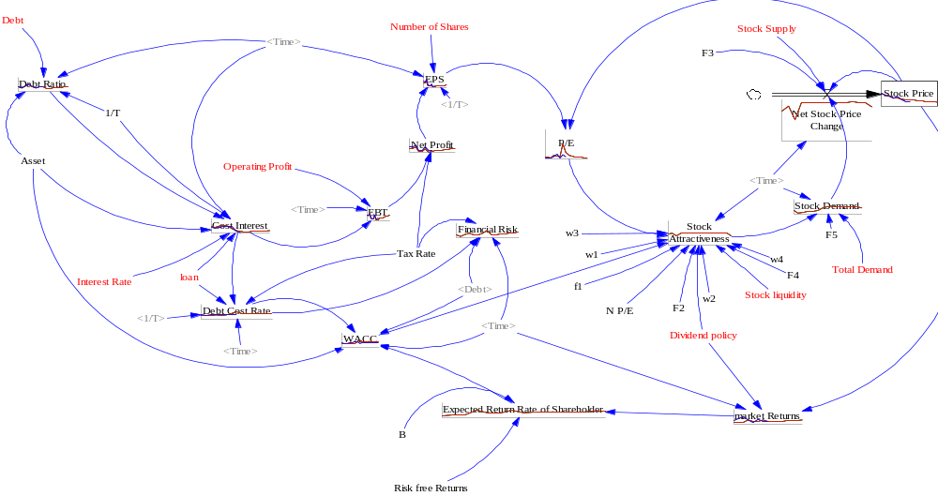
In order to model the behavior of the variables of the research model, the required data were collected from the site related to listed companies and experts’ opinion and the relationship between the variables was established according to the mathematical and logical relationships. The actual data collected from 2011 to 2018 are simulated by Vensim DSS software until the end of 2031 (Figure 9).

Figure 9. The optimal capital structure model of the company

Model validation
The main purpose of model validation in dynamic systems is to ensure the correctness of the structural behavior of the model while paying attention to the modeling process. In this paper, to validate the model structure based on the opinion of experts, and to confirm the validity of the model behavior, the re-behavior test was used. In this test, the results of model simulation are compared with real data in order to ensure the correct operation of the model behavior. In this case, the simulated behavior is generated for the model to be compared with real data. As can be seen in Figures 10, 11 and 12, the actual information and simulation results of earnings per share variables, total debt cost of capital and share price of the company from 2011 to 2018 indicate that the behavior of the studied variables were simulated well.

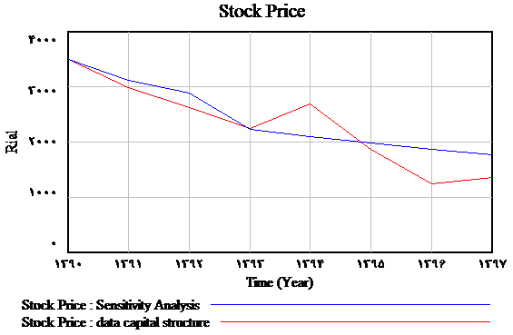
Figure 10. The pattern behavior test based on the price per share
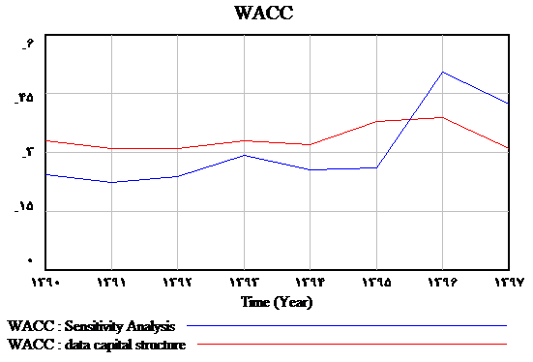
Figure 11. The pattern behavior test based on the total capital cost
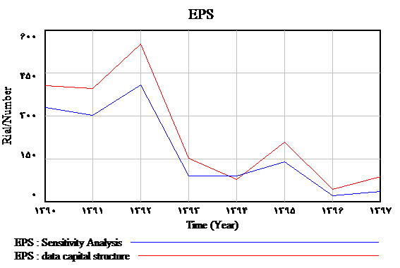
Figure 12. The pattern behavior test based on earnings per share

Valuation Module
To ensure the correctness of simulated results, in addition to reproducing the model behavior, error test indicators were used and the value of key variables was calculated based on the following indicators.
A) Root-mean-square error (RMSE): Based on this index, the smaller the difference between the real data and the simulated one, the more reliable the simulation results can be. Moreover, the closer the value of this index is to zero, the lower the error, and the closer it is to 100%, the higher the error.
B) Inequality coefficient: Another way to measure the deviation of simulated values ​​from real data is to calculate the inequality coefficient. The inequality coefficient will always be between zero and one, the closer this value is to zero, the simulated and real values will be less deviated from each other. Moreover, the closer this value is to one, it means that the performance of the model is not good in predicting.
Due to the importance of error in predicting, identifying the sources of error and reducing it can be very effective in increasing confidence in the results of the model. Large errors may be due to high scattering of random data in the model. The inequality coefficient can be used to find the sources of errors.
The results of error calculation tests are shown in Table 5 in terms of key model variables. As can be seen, the error rate in all the studied variables is at an acceptable level. Moreover, it can be said that the reliability and validity of the approved model and the results of this model can be checked and relied on.

Table 6.
Results of Pattern Validation Statistical Tests
Stock prices | Total capital cost ratio | Debt cost ratio | Test
.02128 | .0293 | .0238 | RMSPE
.10028 | .2375 | .19109 | UT
.0568 | .9798 | .96882 | U^{m}
.111 | .00038 | .0113 | U^{s}
.825 | .01982 | .01988 | U^{c}
1 | 1 | 1 | U^{m} +U^{s} +U^{c}

Sensitivity Analysis
Sensitivity analysis is a mechanism for creating certainty in model-based analyzes and proposed policies. Sensitivity analysis in dynamic models shows the sensitivity of key research variables to research parameters, so we change the parameters to the same extent and examine its effect on key variables. In this section, the sensitivity of total capital cost and debt cost to changes in debt, as well as the sensitivity of share price and earnings per share to changes in debt, and thus the cost of total capital and debt cost will be measured. For this purpose, the amount of company debt is changed by 20% and its effect on the mentioned variable is examined. The change in the value of the share of Figure 13 and the earnings per share of Figure 14 has little effect.
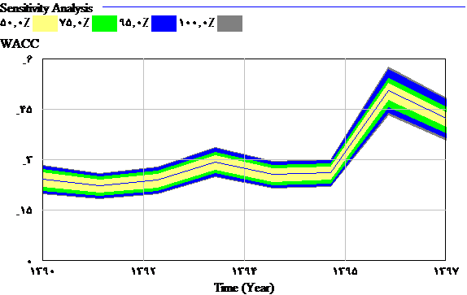
Figure 13. Chart of changes in capital expenditure relative to debt volatility

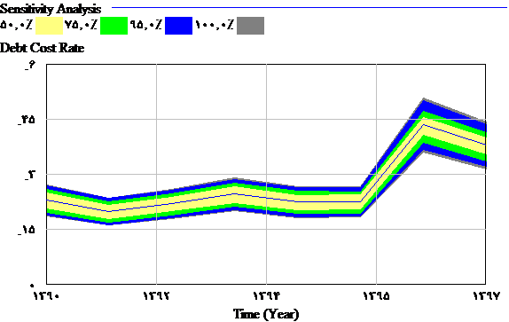
Figure 14. Chart of changes in debt costs relative to debt volatility

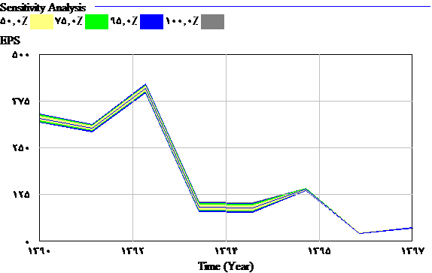
Figure 15. Chart of changes in earnings per share relative to debt volatility

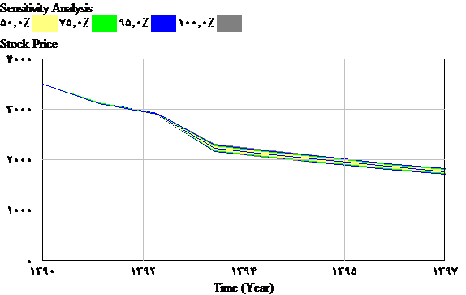
Figure 16. Chart of price changes per share relative to debt fluctuations

Capital Structure Policy
The purpose of this step is to optimize the process of changing key variables according to different policies. Therefore, in order to predict the probable behaviors of the model, by increasing the variable of debt, it reduces the cost of debt and the cost of capital due to tax exemption and has a small effect on earnings per share and a small effect on stock prices as described in the following diagrams (Figures 17-20).
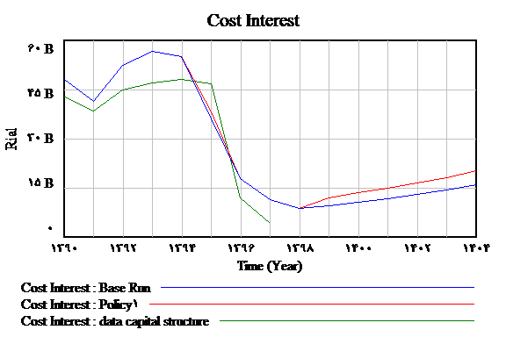
Figure 17. Chart of changes in the amount of debt over the rate of debt expense
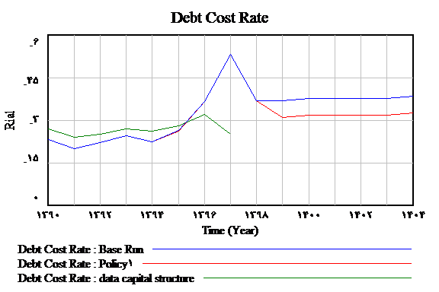
Figure 18. Chart of changes in the amount of debt on the cost of total capital
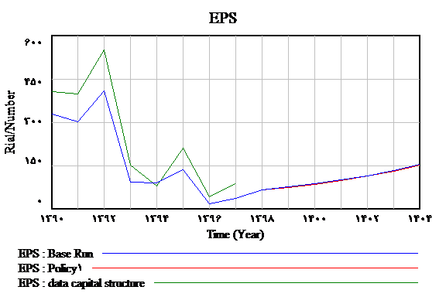
Figure 19. Chart of changes in debt on earnings per share
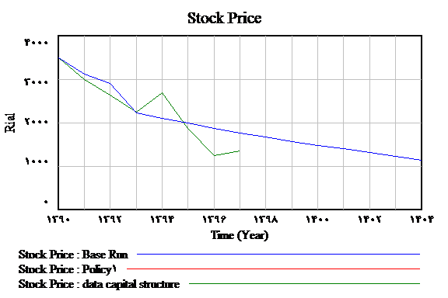
Figure 20. Chart of changes in the amount of debt on the price of each share

Conclusion and Suggestion
In this research, using system dynamics, the capital structure was examined and the behavior of system variables up to 2031 was simulated. In summary, the results of this study indicate that financing through debt in the capital structure of the company has a significant effect on the cost of debt and the cost of capital and it has no significant effect on stock prices. Finally, the share price shows little sensitivity to the company's financial structure. In the historical study of theories and researches in the field of analysis of the relationship between capital structure and company value, the results of research are different from each other and after about six decades of despite the presentation of various theories In the field of capital structure, a comprehensive model has not yet been developed that is able to fully describe and predict the financing behavior and capital structure of companies. By studying similar researches, it can be seen that almost all researches have tried to test one of the theories of capital structure and certain variables through linear regression processes or neural networks and no comprehensive study has been done in this field. In this research, we have tried to identify the most important variables by reviewing the literature and provide a comprehensive model. And with the systemic dynamics approach, all the factors affecting the capital structure have been studied dynamically and non-linearly. The results of previous studies show that none of the current theories and models alone is able to fully explain the factors affecting the optimal structure of corporate capital because some of these theories believed that debt is in the capital structure of companies effective. While others believe is has no effect. Thus, it seems that the biggest problem is the lack of a comprehensive theory that can fully explain the financing behavior and capital structure of companies, so in this study, with a dynamic approach, a system for modeling this issue is selected. This problem has been solved largely. It is suggested that this modeling be completed by adding newer variables and simulated and tested in the real world.

References
Alexandra Nenu, E., Vintila, G., & Gherghina, S. Ch. (2018). The Impact of Capital Structure on Risk and Firm Performance: Empirical Evidence for the Bucharest Stock Exchange Listed Companies. ID International Journal of Financial Studies, 6(2), 41. https://doi.org/10.3390/ijfs6020041
Ardabili, M. H., & Bigler, K. (2006). Investigating the Relationship between Capital Structure Criteria and Performance Characteristics of Companies Listed in Tehran Stock Exchange. Accounting Knowledge and Research Quarterly, 2(6), 46-55.
Ardakani,S.S, & Tabataba’i nasab,S.M.(2020). Marketing Strategy Evaluation by Integrating Dynamic Systems Modeling and Network Data Envelopment Analysis, Journal of System Management, Issue 1, pp. 019-034
Bagherzadeh, S. (2003). Explaining the capital structure pattern of companies listed on the Tehran Stock Exchange. Journal of Financial Research, (16), 23-47.
Booth L, Aivazian, V., Demirguc-Kunt, A., Maksimovic, V. (2001). Capital Structure in Developing Countries. The Journal of Finance, LVI(1), 87-130.
Chen, J., & Strange, R. (2005). The Determinants of Capital Structure: Evidence from Chines Listed Companies. Economic Change and Restructuring, 38, 11–35. https://doi.org/10.1007/s10644-005-4521-7
Danso, A . , & Adomako, S . (2014). The financing behavior of firms and financial crisis. Managerial Finance, 40 (12 ), 1159 –1174.
Eslami Bidgoli, Mazaheri Tahmasb Ghulam Reza (2009) Hierarchy in explaining the structure of capital. Journal of Accounting Research, No. 3, p.4.
Fama, E., & French, K. (1992). The Cross-Section of Expected Stock Returns. The Journal of Finance, 2, 427-465.
Forrester, J. W., & Brink, H. M. (1999). Industrial Dynamics. MIT Press.
Gaud, P., Hoesli, M., & Bender, A. (2007). Debt-equity choice in Europe. International Review of Financial Analysis, 16(3), 201-222. https://doi.org/10.1016/j.irfa.2006.08.003
Hanna, R. W. (2020). Capital Structure Determinants, Dynamics and Speed of Adjustment Towards Target Leverage: A Systematic Literature Review of Empirical and Theoretical Disciplines. International Journal of Recent Scientific Research, 11(02), 37517-37528. http://dx.doi.org/10.24327/ijrsr.2020.1102.5127
Hassani Hassan and Pakmaram Asgar, 2017, Factors Affecting the Capital Structure of Companies with Emphasis on Business Cycle , https://civilica.com/doc/872536
Khan, A., Qureshi, M. A., & Davidsen, P. I. (2020). A system dynamics model of capital structure policy for firm value maximization. Systems Research and Behavioral Science, 2020, 1–14. https://doi.org/10.1002/sres.2693
Kordistani, Gholamreza and Pirdavari, Tanaz, 2012, Capital Structure, Experimental Test of Market Scheduling Theory, https://civilica.com/doc/1124555
Kordistani Gholamreza, & Najafi Imran, M. (2008). A Study of Determinants of Capital Structure; Experimental Test of Static Balance Theory vs. Hierarchical Theory. Financial Research, 10(25), 73-90.
Kymiagari, A. M., & Einali ,Soodabeh. (2008). Presenting a comprehensive model of capital structure (Case study of companies listed on the Tehran Stock Exchange). Financial Research, 10(25), 91-108.
Lopes, N., Cerqueira, A., & Brandao, E. (2017). The Determinants of Capital Structure: impact of institutional determinants and subprime crisis. MSc thesis, Faculty of economic, University of U. Porto.
Mousavi Hanjani, S.M., & Iranban, S.J. (2019) The Relationship between Diversification Strategy, Capital Structure and Profitability in Companies Listed
in the Stock Exchange by Combining the Data Line and VAR Methods. Journal of System Management. Vol 5, No. 1.,41-60
Mousavi Haghighi, M. H., & Sotoudeh, F. (2013) Simulation of Stock Behavior Dynamics Pattern in Tehran Stock Exchange. Strategic Management Studies, (14), 35-52.
Namazi, M., & Shirzadeh, J. (2005). Investigating the Relationship between Capital Structure and Profitability of Companies Listed in Tehran Stock Exchange (with Emphasis on the Type of Industry). Accounting and Auditing Reviews, (42), 75-95.
Qiu, M., & La, B. (2010). Firm Characteristics as Determinants of Capital Structure in Australia. International Journal of the Economics of Business, 17(3), 277-287. https://doi.org/10.1080/13571516.2010.513810
Rajan, R.G., & Zingales, L. (1995). What do We Know about Capital Structure? Some evidence from International Data. The Journal of Finance, 50(5), 1421-1460. https://doi.org/10.2307/2329322
Sarlak, N., Faraji, O., & Bayat, F. (2015). The relationship between financial characteristics of the company and the structure of capital in the life cycle of the company. Quarterly Journal of Financial Accounting and Auditing Research, 7(27), 1-21.
Sterman, J. D. (2000). Business Dynamics. McGraw-Hill, Boston.
Sunder, L. S., & Myers, S. C. (1999). Testing Static Tradeoff Against Pecking Order Models of Capital Structure. Journal of Financial Economics, 51, 219-244. https://doi.org/10.1016/S0304-405X(98)00051-8

¹ Authors Affiliation ² Authors Affiliation ³ Department, Faculty, University, City, Country

